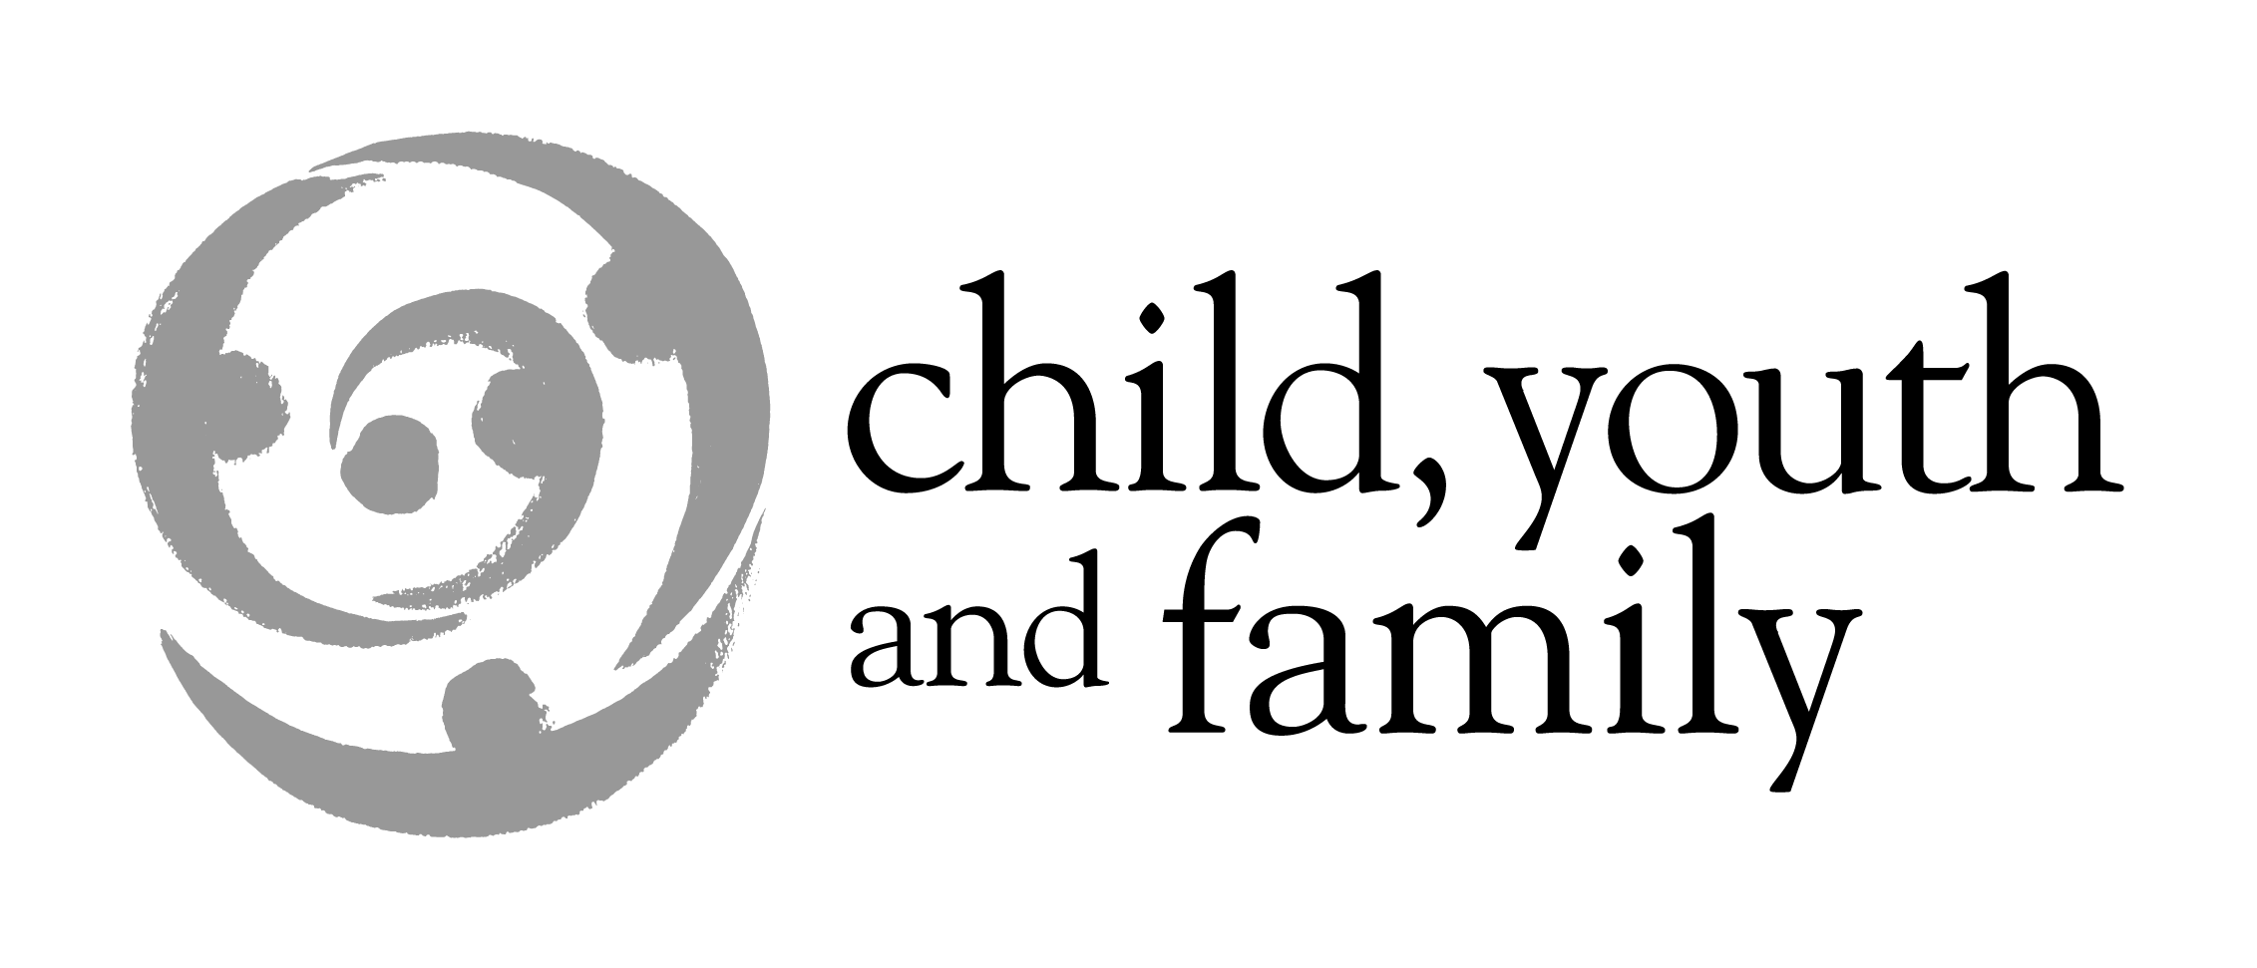

Report # REP/04/8/121

25 August 2004

The Associate Minister for Social Development and Employment (Child, Youth and Family)

SPEECH NOTES FOR NZ ASSOCIATION OF CHILD AND FAMILY SUPPORT AND COMMUNITY SERVICES

Purpose of Report

- The purpose of this report is to provide you with speech notes for a speech to be delivered at the Annual Conference of the New Zealand Association of Child and Family Support and Community Services.

Introduction, including background information about the Association
- Thank you for the invitation to speak again. I enjoyed the opportunity to speak to you at last year’s “lifting our game” conference in Christchurch.
- The Association exists to:
- ‘Give a voice to organisations approved as providers of Child and Family Support and Community Services’ and to develop a strong working partnership with Child, Youth and Family for its members. The community and voluntary sector is absolutely vital in helping Child, Youth and Family achieve its outcomes of safety and security for children and young people. We often hear about how protecting children is a shared responsibility. It can’t just be left to Government – in particular to CYF – to parent these children. You are the organisations which have actually heeded these calls, and taken on that responsibility.
- ‘Promote assistance to children, young people and their families through better co-operation between services, Child, Youth and Family, and other Government departments’ – such as the Ministry of Social Development and the Department of Internal Affairs. Inter-agency and inter-sector coordination has been a key area of focus during this Government’s time in office, and particularly for the Social Sector. Strategies like the Care and Protection Blueprint, Effective Responses and the Early Intervention have focused on improving this. Working with organisations like yours – often through the Association is how this ideal is realised.
- ‘Identify issues that challenge good practice, and seek solutions to these issues’. This is largely what these two days are about: facing up to the challenging issues; the real world issues which face those who choose to work with children needing care and protection, and to deal with difficult adolescents, and exploring the ways in which these should be addressed.
The theme for this year’s Conference is “Harekeke”. This is about celebrating the Creativity, Diversity and Unity which all the different members bring to the organisation. It is also about us being creative in the way we work with different cultures families.
Creativity
- There is a real need in social services for creativity – for thinking outside the square. To a certain extent we are limited in our choices: the main constraint being the limit in the amount of money we have to spend. Sometimes we are limited in our ability to work well with families because of their circumstances, but most of the time there is room to be creative and open-minded.
Diversity
- New Zealand is a diverse country, and becoming more so. We have historically seen ourselves as being bi-cultural. We have increasing numbers of immigrants, especially from Asian and Pacific countries, settling here every year. This is a challenge for the social sector to look at how we interact with these different cultures, and respond their needs appropriately. Child, Youth and Family have separate strategies for responding the unique needs of Maori and to Pacific Island peoples.
Unity
- Finally, Unity. Much as we need to recognise our differences, we also need to recognise those things we have in common. We are all here to help children, young people and their families. With everything we do the overriding principle remains the safety and security of the children we deal with.
Child, Youth and Family
- A lot has happened for Child, Youth and Family since I spoke to you this time last year. Child, Youth and Family in a year: the Report from the Baseline Review was released and we’ve seen two Chief Executives, there has been restructuring of the Department, and of course shortly before that they received the added bonus of gaining me as its Minister!
- The Baseline Review told the Department to focus on its core business: those children and young people most in need of safety and security, and we’ve set about doing that. Despite having an enormous increase in workload in the last year, we are actually managing to respond to the challenge better than before. We know we have a long way to go – we have a long way to go to even implement the projects from the Baseline Review – but things are genuinely getting better.
- The implementation of the review involves more than just the Department. It has lead to the Family Services Strategy at the Ministry for Social Development. There is also the Early Intervention project, led by MSD, but involving a number of other departments, including Health, Education, Pacific Island Affairs, Te Puni Kokiri and Child, Youth and Family itself. The focus of this project is on helping children at risk of poor outcomes. This is about helping children aged 0-6 at risk of poor outcomes early on – well before they come to Child, Youth and Family’s door, and you’ll be hearing from John Angus and Ross Mackay later on today on how important this is.
- The Effective responses project is another – this is looking at averting children and young people who are looking to be at immediate risk of coming to the attention of CYF. This is the kind of support from other Government agencies that will make the work of Child, Youth and Family a lot more manageable in the future. With the added vital support of the community, and service providers like yourselves, I am positive that we are on the right track.
Strengths-based practice
- One of the themes being discussed at the conference is strengths-based practice. Strengths-based practice is a philosophy we are working hard at growing within Child, Youth and Family – particularly with our social workers, and it’s something I’d like to spend a few minutes talking about today.
- Strengths-based practice encompasses all of the different aspects of Harakeke. It is about an approach to people which depends upon positive attitudes about people’s dignity, their rights, their uniqueness as well as their commonalities, their abilities and their capacity to learn, grow and change. It seeks to use and mobilise people’s strengths to find solutions to their problems.
- Strengths-based practice is primarily about developing good working relationships. It is defined by:
    - An interpersonal relationship which is collaborative and mutually enriching
    - Assessment that is focused on resources within each person, as well as within their social environment
    - Planned change that is directed by the hopes, dreams and aspirations of each unique participant
- Contrary to wide-spread belief, strengths-based practice does not seek to minimise or sanitise problems. A lot of people seem to think that it’s about looking at a beaten child, and saying to the family “well done, at least you didn’t’ kill them”. This is simply not true. Strengths-based practice is sitting down with the family and being honest about what’s gone on, and what is going on within their family. The difference is that it looks to address problems in the context in which they sit – using the strengths, resources and wisdom of the people involved with the problem.
- Strengths-based social work practice is firmly based on a set of guiding principles. The first of these is the need to understand the position of all parties: social workers seek to identify and understand the values, beliefs and meanings people perceive in the description of their circumstances. This helps the social worker to respond to the uniqueness of each situation without blaming, and to move towards plans that people are more likely to use. We all have a set of values we think to be “common sense”, but “common sense is merely the set of prejudices we begin with”. The first principle is simply about empathising: working with the family, rather than against them.
- The second principle is to find exception to the unwanted behaviour. In all circumstances, no matter how dire, there will have been times when the problem behaviour was either not happening, or was less of a problem. Social workers need to look at what was happening when the problem was not happening, or at least when it was reduced. This gives hope – both to the social worker, and to the family by showing that the problem isn’t always there, and so doesn’t ever have to be there. These kinds of exceptions can also show solutions that have worked in the past. An example with a parent who has been hitting their children would be asking about times when they might have hit the children but didn’t. what prevent them from doing it? What else occurred in that circumstance that didn’t’ happen when the child was hit? There will be times when no exceptions can be found, and this may indicate a more serious problem…but this would be the exception!
- The third principle is to try and uncover people’s strengths and resources. Social workers need to identify and highlight the positive strengths, resources and capabilities of people. This creates an expectation and awareness of possibility and capacity which prevents the problems from overwhelming and discouraging everyone involved. The strengths people have internally – and within their families/ whanau and communities can be hidden or unobserved in the intensity of the problem. Making sure that they are noticed can create a sense of hope and balance about the problem, the person and their ability.
- The fourth principle is to focus on goals, or the person’s picture of the future. It is very important to understand the picture that people have for their future: this is a view of what a solution may look like. Solutions to these sorts of problems don’t come off the rack – they’re all made to measure. When both the worker and the family are clear about what will be happening and what the family will be doing differently without the problem, a possible plan of action with the vision of a positive outcome can be established. The worker and family may be able to use their ideas, but if necessary have two lots of goals to achieve.
- The fifth principle is to scale safety and progress. It is important to identify people’s sense of safety and progress throughout, beginning at the first interview. This allows clear comparisons with workers’ judgements, as will as a means of recognising that change is made in small steps. The worker ensures change is noticed by observing, measuring and highlighting changes to risk or behaviour, and emphasising what people are doing that is making a difference.
- The final practice principle is to assess the willingness of the people involved. Any plans created must be discussed to determine people’s willingness and ability to go through with the plans before trying to implement them.
Example
- I was told about this case as an example of Strengths-based practice. An 8 year old Indian girl, who had been living in New Zealand with her family for 8 months, turned up at school one day with serious burns to the back of her neck. She said that they had been done by her father for failing to do her homework. Heated tongs had been used on the girl by the father in a kind of ritualistic abuse.
- Social workers wanted to carry out a safe and thorough investigation with the assistance of interpreters and cultural advisors despite the fact that both parents spoke good English. The social worker asked herself how she could build a positive relationship with the family in order to keep the children safe.
- The parents were invited to bring the children in to the office where they were interviewed and a previously prepared warrant to remove both children was executed. The social worker then said to the parents “how are you going to keep your children safe, because it’s not their behaviour which is the problem?” bvy asking this, the social worker offered them the opportunity to develop a safe plan around their children. The father explained that his behaviour towards the girl was how he had been parented which he thought was a sound method of discipline. Extended family patterns were explored and the parents were invited to come back with a plan. The children meantime were placed in the Family Home.
- Three days later the parents made contact with the social worker with a plan that the father would leave the home and allow the children to return to the mother, who was not implicated. He would agree to attend any counselling/parent education necessary, and would only return to the home when the family felt safe. The social worker applied for a Declaration and an interim custody order, and made a referral for a Family Group Conference. The social worker continued to support the family to understand the abusive nature of the methods they had learned, or learned to live with, and to build on the family strengths. The father and family were referred to an Indian psychologist who continued to develop their understanding and support the parents’ resolve to positively parent these children. Following the formal review of the FGC plan, the children were returned home and application to discharge all court orders was agreed by the Court.
Conclusion
- I’d like to finish by thanking you for the invitation to talk again this year. I look forward to continuing and strengthening the important relationship between Child, Youth and Family and the Association.

Recommendation
- It is recommended that you:

Note the contents of this report

Agree/ disagree

Hon Ruth Dyson
Associate Minister for Social Development and Employment (Child, Youth and Family)

Date: ______________ Seen / Approved

Albert Einstein

